NANDHA ENGINEERING COLLEGE

**(AutonomousInstitution)**

Erode-638 052



**TABLEAU-TWO CREDIT COURSE**

**IV–Semester**

**B.Tech-Artificial IntelligenceandDataScience**

**NAME :S. KOWSALYA**

**BRANCH :B.TECH AI & DS**

TABLEAU

**Tableau** is a powerful data visualization and business intelligence tool that helps people see and understand their data. It allows users to connect to various data sources, transform raw data into interactive dashboards, charts, and graphs, and share insights easily.

Some key points about Tableau:

* It supports **drag-and-drop** for creating visuals.
* It connects to databases, spreadsheets, cloud services, and big data.
* It’s used for **data analysis**, **reporting**, and **decision-making**.
* There are different products like **Tableau Desktop**, **Tableau Server**, and **Tableau Public**

**USES:**

👉 **Tableau** is one of the best tools for **turning data into clear, interactive visuals** — *without heavy coding*.

Here's why people love it:

* **Easy to Use**: Drag-and-drop interface. You can build complex dashboards without programming.
* **Powerful Data Analysis**: It handles tons of data from different sources (Excel, databases, cloud, etc.).
* **Beautiful Visuals**: Charts, graphs, maps — all polished and customizable.
* **Interactive Dashboards**: Users can filter, zoom, and explore the data live.
* **Fast Insights**: Once your data is connected, you can explore patterns and trends really quickly.
* **Business Ready**: Used heavily for reporting, decision-making, and storytelling with data.

Some real-world examples:

* A sales manager tracking real-time revenue.
* A marketing team seeing customer behavior patterns.
* A supply chain team monitoring shipments and inventory.

**SALES PRODUCT REPORT**

📈 Tableau Project Overview: Sales Records Analysis

## 1. **Objective**

* Analyze 10,000 sales transactions to find trends, patterns, and insights.
* Build an interactive dashboard for business decision-making.

## 2. **Data Source**

* File: **10000 Sales Records.csv**
* Columns likely include: Region, Country, Item Type, Sales Channel, Order Priority, Order Date, Units Sold, Unit Price, Revenue, Cost, Profit, etc.

## 3. **Key Questions**

* What regions/countries generate the most revenue?
* Which item types are the best and worst sellers?
* How do profits vary by sales channel (Online vs. Offline)?
* Which months or years had the highest sales?
* Are there patterns in order priority and revenue?

## 4. **Planned Visualizations**

* **Sales by Region (Map View)**
* **Revenue and Profit Over Time (Line Chart)**
* **Top-Selling Products (Bar Chart)**
* **Sales Channel Comparison (Pie or Donut Chart)**
* **Order Priority vs Profit (Scatter Plot)**

## 5. **Dashboard Features**

* Filters: Region, Country, Item Type, Year
* Tooltips showing extra details on hover
* Drill-down from Region → Country
* KPIs at the top: Total Revenue, Total Profit, Total Units Sold

## 6. **Outcome**

* A clear, interactive Tableau dashboard that helps management:
  + Find growth opportunities
  + Identify weak areas
  + Make data-driven decisions

# 🛠 Steps to Execute the Sales Records Project

## Step 1: **Set Up**

* Install and open **Tableau** (use Tableau Public if you don't have a license).
* Prepare your file: **"10000 Sales Records.csv"** (looks good already!).

## Step 2: **Connect to the Data**

* In Tableau, click **Connect** → **Text File** → select your CSV file.
* Preview your data to check: Are all columns properly recognized (especially dates and numbers)?

## Step 3: **Data Cleaning (if needed)**

* Check for:
  + Wrong data types (e.g., make sure "Order Date" is a **Date** field, not text).
  + Empty/missing values.
* Rename fields if necessary (for easier reading).

👉 You can do basic cleaning right inside Tableau or in **Data Interpreter**.

## Step 4: **Understand Your Data**

* Explore:
  + What are the main fields?
  + Which fields are **Dimensions** (categorical, like Region) and which are **Measures** (numerical, like Revenue)?

## Step 5: **Create Basic Visualizations**

Start with simple charts:

* **Bar Chart**: Total Revenue by Region.
* **Line Chart**: Revenue over Time (Order Date).
* **Pie Chart**: Sales Channel split (Online vs Offline).
* **Map**: Revenue by Country (use the "Country" field).
* **Scatter Plot**: Profit vs Units Sold colored by Order Priority.

## Step 6: **Combine into a Dashboard**

* Create a new **Dashboard**.
* Drag your visualizations onto the canvas.
* Arrange neatly (try using grids).
* Add:
  + **Filters**: Region, Year, Item Type.
  + **KPIs**: Total Revenue, Profit, Units Sold (using Summary Cards).
  + **Tooltips**: Show additional data on hover.

## Step 7: **Add Interactivity**

* Enable filters to **control multiple charts**.
* Allow users to **click on a region** and see only that region's details.
* Add **hover highlights** for better user experience.

## Step 8: **Final Touches**

* Tidy up titles, labels, fonts.
* Use color wisely:
  + Positive profits = Green
  + Negative profits = Red
* Double-check spelling and formatting.

## Step 9: **Publish or Export**

* Save the dashboard.
* Publish it to **Tableau Public** (if using free version) or export as a **PDF** or **Packaged Workbook (.twbx)**.

In this project, we aim to analyze a dataset containing 10,000 sales records using Tableau, a powerful data visualization tool. The first step is connecting the CSV file to Tableau. After connecting, we perform basic data cleaning by checking for missing values, incorrect data types, and formatting issues. Properly organizing the data is crucial: we categorize fields into **Dimensions** (such as Region, Country, Item Type, and Sales Channel) and **Measures** (such as Revenue, Profit, and Units Sold). Dimensions are descriptive categories, while Measures are numeric values that we can sum, average, or otherwise analyze.

Once the data is ready, we move on to creating visualizations. Different types of charts help us view the data from various perspectives. For example, a **bar chart** can show total revenue by region, a **line chart** can display revenue trends over time, and a **pie chart** can compare sales channels like Online and Offline. We also create a **map** to see which countries have the highest sales and a **scatter plot** to study the relationship between profit and units sold, colored by order priority. Each chart focuses on answering important business questions, like where the highest profits are made or which product types are most popular.

After creating the individual charts, we combine them into a **dashboard**. The dashboard is the main page where all the visualizations come together to give a full overview of sales performance. We organize the dashboard using layouts and containers to make it clean and easy to read. Filters are added, allowing users to focus on specific regions, years, or product types. We also create **KPI (Key Performance Indicator)** cards, such as Total Revenue, Total Profit, and Total Units Sold, to highlight the most important numbers at the top of the dashboard. These KPIs quickly show the health of the business without needing to read through detailed charts.

**TOTAL REVENUE VS REGION**

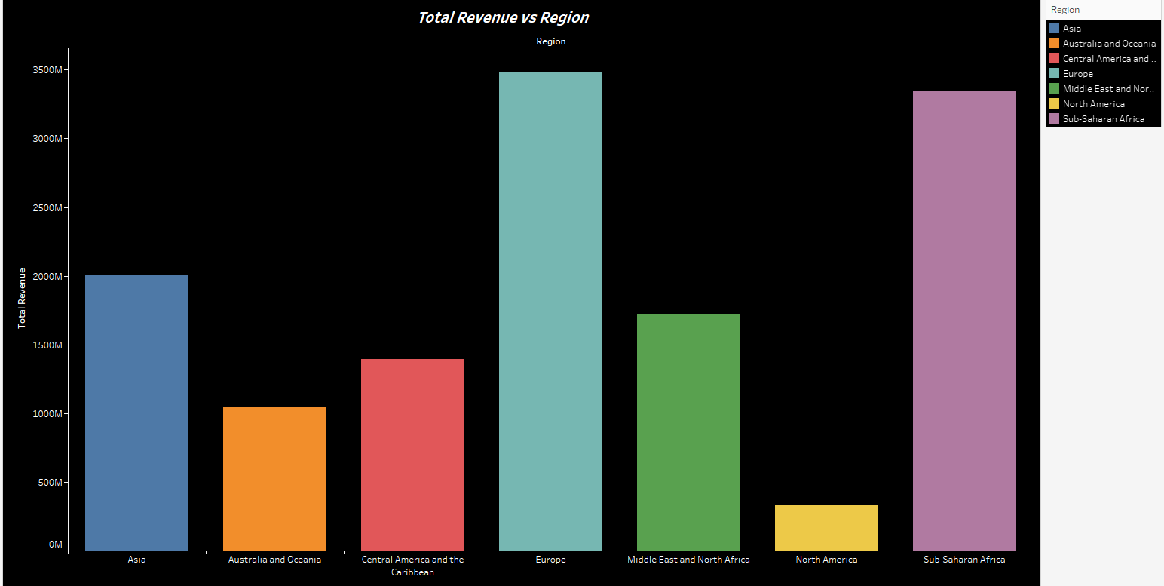

**Definition**

A **bar chart** is a visual tool used to represent categorical data with rectangular bars, where the length or height of each bar corresponds to a particular value. In this specific context, the chart is used to compare two key measures from your dataset: **Total Revenue** and **Sales**. By displaying these measures side by side (or on dual axes), you can quickly see how revenue generation relates to sales volume across different categories—such as regions, product lines, or time periods. This comparison not only highlights performance differences but also suggests areas for further investigation, such as pricing strategies, market penetration, or operational efficiencies.

**Process to Create the Bar Chart in Tableau**

1. **Data Preparation**

* **Connect to Your Data:**
  + Open Tableau and connect to your dataset (e.g., Excel, CSV, SQL database) that includes fields for Total Revenue, Sales, and any categorical dimensions (like Region, Category, or Date).
* **Review and Clean:**
  + Verify that the Total Revenue and Sales fields are both recognized as numerical measures.
  + Check for any data quality issues (duplicates, missing values) and address them as needed.
* **Aggregate if Necessary:**
  + If your dataset has multiple records per category, ensure you aggregate the figures (typically using the SUM function) so that each category displays a single Total Revenue and Sales value.

2. **Building the Visualization**

* **Select the Dimension and Measures:**
  + Identify the dimension you want to analyze (e.g., Region, Product Category, etc.).
* **Drag the Dimension to Columns:**
  + Place the chosen category on the **Columns** shelf in Tableau.
* **Create the Bar Chart:**
  + Drag the **Total Revenue** measure to the **Rows** shelf. Tableau will automatically generate a bar chart showing revenue for each category.
* **Include Sales Data:**
  + Option 1: **Dual-Bar (Grouped) Chart**
    - Drag the **Sales** measure onto the same Rows shelf. Tableau may automatically create a combined chart. If not, drag “Measure Names” to the **Color** shelf, then drag “Measure Values” to the **Rows** shelf, ensuring both Total Revenue and Sales are included.
  + Option 2: **Dual-Axis Chart**
    - Create a dual-axis by placing Total Revenue on one axis and Sales on the other. Right-click the second axis and select “Dual-Axis,” then synchronize axes if necessary. Use different colors to differentiate between the two measures.
* **Customize the Chart:**
  + Add data labels to show numerical values directly on each bar.
  + Adjust colors and fonts to ensure clarity and visual appeal.
  + Configure tooltips to display additional context when hovering over individual bars.

3. **Refine and Interpret**

* **Annotate Key Insights:**
  + Use annotations to highlight major differences in performance between Total Revenue and Sales. For example, you might point out segments where high revenue is achieved despite lower sales, indicating premium pricing or higher margins.
* **Review Scale and Format:**
  + Confirm that the scales for both Total Revenue and Sales are appropriate, ensuring the chart accurately reflects the differences in these measures.
* **Test Interactivity (if applicable):**
  + If you plan to publish the visualization on an interactive dashboard, test any filter or highlight actions to allow users to delve deeper into specific categories.

**REVENUE BY COUNTRY AND ITEMTYPE**

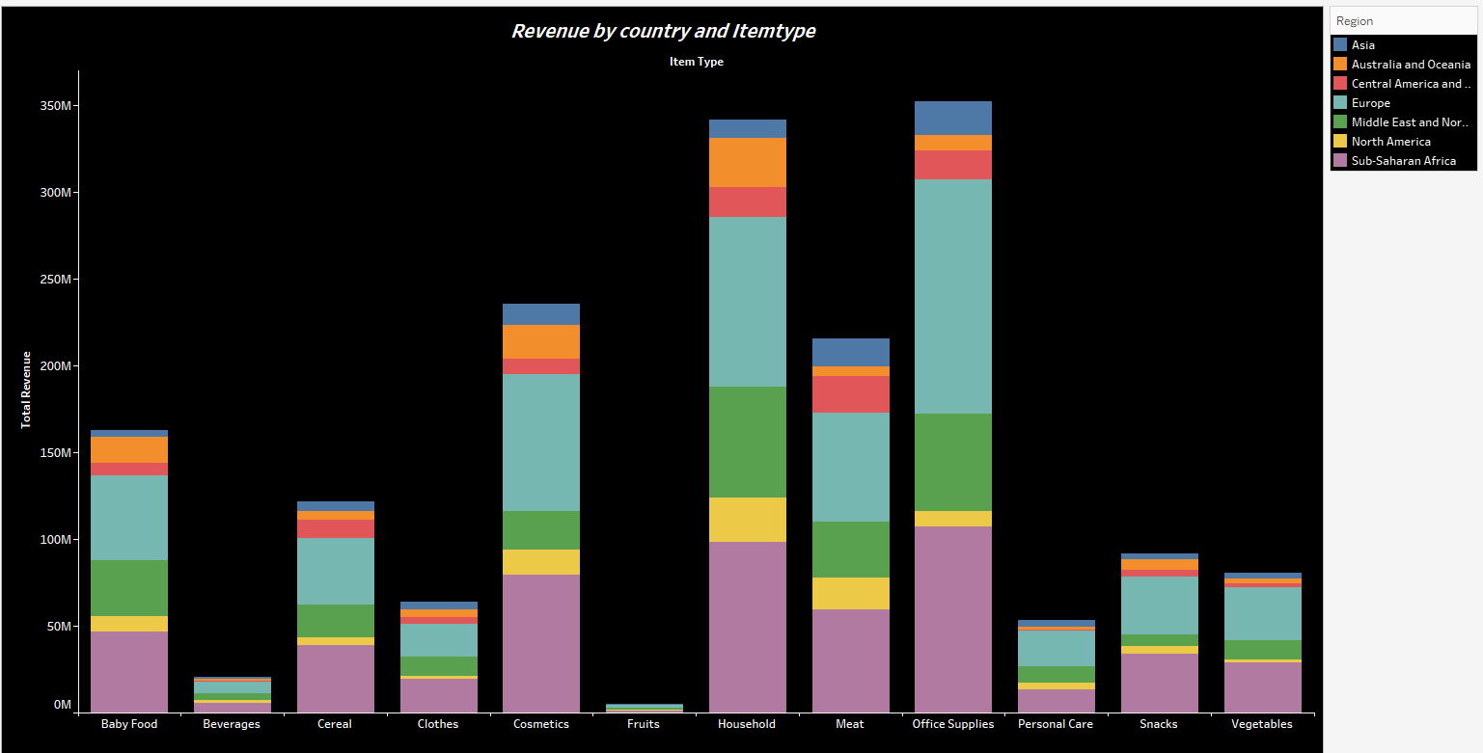

**Definition**

A **horizontal bar chart** is a type of data visualization in which categorical data is represented by rectangular bars that extend horizontally. In this context, each bar represents an item type (such as Baby Food, Beverages, Cereal, etc.), and the length of the bar corresponds to the total revenue. To go deeper, each bar is segmented using colors to depict the contribution of different countries (or regions) toward that revenue. This layout makes it easier to compare categories side by side and to examine how revenue is distributed across countries for each item type—especially useful when there are many categories or when category labels are long, as horizontal bars enhance readability.

**Process to Create the Horizontal Bar Chart in Tableau**

1. **Data Preparation**

* **Connect and Review Your Data:**
  + Open Tableau and connect to your dataset (e.g., Excel, CSV, or SQL database).
  + Verify you have the necessary fields:
    - **Item Type** (categorical dimension, e.g., Baby Food, Beverages, etc.).
    - **Country** (or region, which represents the different countries contributing to revenue).
    - **Revenue** (numerical measure, ideally already aggregated or ready for summing).
* **Clean and Aggregate:**
  + Ensure that the revenue data is clean and that the data types for revenue, item type, and country are correctly set.
  + If your dataset contains multiple records for the same category, use the SUM() aggregation to compute the total revenue for each item type.

2. **Building the Visualization**

* **Set Up the Horizontal Layout:**
  + **Drag the Dimension:**
    - Place the **Item Type** dimension on the **Rows** shelf. This sets up each item type as a separate row, which is ideal for horizontal bar charts.
  + **Drag the Measure:**
    - Place the **Revenue** measure on the **Columns** shelf. This will draw bars whose lengths represent revenue amounts.
* **Stack the Bars by Country:**
  + To show how different countries contribute to the total revenue:
    - Drag the **Country** (or region) dimension to the **Color** shelf on the Marks card.
    - Tableau will automatically split each horizontal bar into segments, each colored to represent a different country.
  + Alternatively, if you prefer further detail, you can also drag **Country** to the **Detail** shelf to ensure each segment is clearly differentiated.
* **Customization & Orientation:**
  + If you initially create a vertical bar chart, simply swap the axes by clicking the "Swap" button on the toolbar. This converts the chart into a horizontal bar layout.
  + Adjust the color palette to ensure the segmentation by country is distinct and easily interpretable.

3. **Enhance the Chart for Clarity**

* **Add Data Labels:**
  + Drag the Revenue measure to the **Label** shelf so that each segment displays its revenue value.
  + Format these labels (e.g., currency format, rounded figures) for clarity.
* **Tooltips and Annotations:**
  + Edit the tooltips to provide additional information such as the percentage contribution of a country to the overall revenue for that item type.
  + Add annotations to highlight insights, like the item types where certain countries dominate revenue.
* **Fine-Tune Visual Design:**
  + Adjust fonts, bar borders, and other stylistic elements to maintain consistency with your dashboard’s overall look.
  + Consider using a legend that clearly maps colors to specific countries or regions.

**COUNTRY VS SALES**

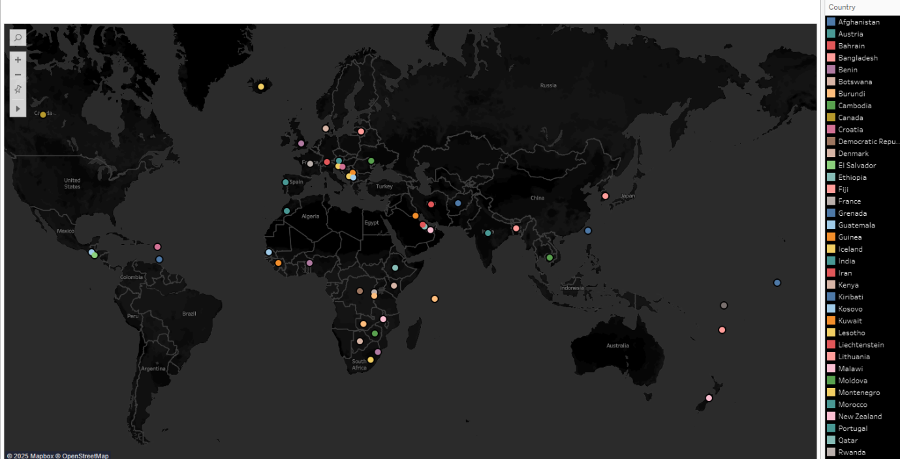

## **Definition**

A **map chart** is a visualization tool that places data points on a geographical map by aligning specific data values—such as sales—with the corresponding countries. In this context, the map chart uses the **Country** field to determine geographic locations and associates the **Sales** measure with each location. Typically, the sales values are encoded with visual properties like color intensity or mark size. This approach allows viewers to quickly grasp geographical trends, identify regions with high or low sales, and observe spatial variations that may relate to market performance, regional strategies, or underlying socioeconomic factors.

## **Process to Create the Map Chart in Tableau**

### 1. **Data Preparation**

* **Connect to Your Data:**
  + Open Tableau and connect to your dataset (which includes at least two fields: Country and Sales).
  + Ensure that the **Sales** field is properly recognized as a numerical measure and that the **Country** field has a geographic role assigned. If not, right-click the Country field and select the appropriate geographic role (e.g., Country/Region).
* **Data Integrity and Aggregation:**
  + Make sure there are no significant data quality issues such as duplicate records or missing country names.
  + If your dataset includes multiple rows per country, aggregate the sales data (typically using the SUM function) so that each country has a single, comprehensive sales value.

### 2. **Building the Base Map**

* **Establish the Map View:**
  + Drag the **Country** field onto the canvas. Tableau will interpret this as a geographical dimension and automatically plot the corresponding locations on a map.
  + Alternatively, double-clicking the Country field will generate a basic map view.
* **Integrate the Sales Measure:**
  + To visually encode the sales data, drag the **Sales** measure to the **Color** shelf on the Marks card. This will adjust the color intensity of the map marks based on the aggregated sales value.
  + Optionally, you can also drag Sales to the **Size** shelf, which visually represents the sales magnitude by varying the size of the marks (e.g., circles) on the map.

### 3. **Customizing the Visualization**

* **Select an Appropriate Mark Type:**
  + Ensure that the Mark type is set to “Circle” or another suitable symbol that clearly represents data points on the map.
* **Adjust Color and Size Settings:**
  + Customize the color palette so that higher sales values are represented by more intense or contrasting colors.
  + Fine-tune the size range for the marks to ensure clarity, especially when there are many data points with varied sales values.
* **Enhance Tooltips and Labels:**
  + Edit the tooltips to include key details like the name of the country and its corresponding total sales value.
  + If needed, add labels to the marks for immediate data recognition, but be mindful not to clutter the map.

### 4. **Enhance Interactivity and Presentation**

* **Interactive Filters:**
  + Add filters (e.g., for time, product categories, or regions) to allow users to drill down into specific segments of the data.
  + Enable zoom and pan controls so that viewers can explore regions in detail.
* **Legends and Annotations:**
  + Use a legend to clearly indicate what the different colors or sizes represent in terms of sales values.
  + Add annotations to highlight regions with exceptionally high or low sales, providing contextual insights that can guide further analysis.

**UNITSOLD VS PROFIT**

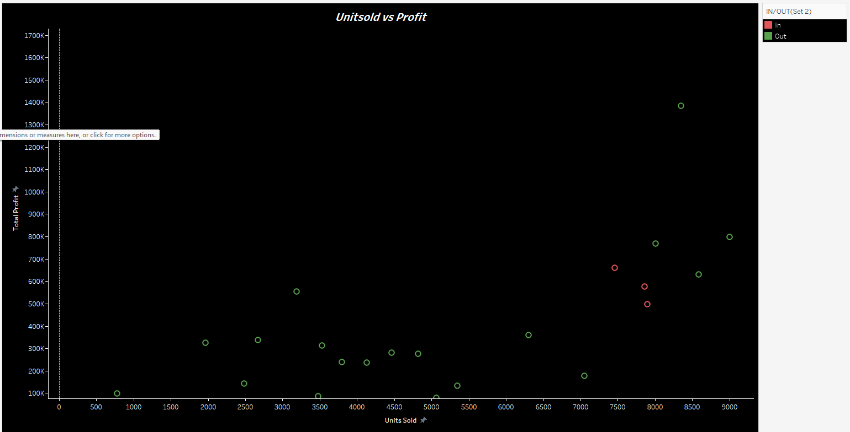

## **Definition**

A **scatterplot** is a type of chart that displays the relationship between two quantitative variables using dots or markers. In this case, the scatterplot illustrates the relationship between the number of **Units Sold** (displayed on the x-axis) and the **Total Profit** (displayed on the y-axis). Each point on the chart corresponds to a data record in your dataset, and these points can be color-coded based on an additional categorical variable—in this instance, the "IN/OUT(Set 2)" field, which differentiates data as "In" (red) or "Out" (green). This visualization is essential for identifying trends, correlations, or outliers. In the example, a general trend shows that as the number of units sold increases, total profit tends to rise, albeit with some variability.

## **Process to Create the Scatterplot in Tableau**

### 1. **Data Preparation**

* **Connect to Data:**
  + Open Tableau and connect to your dataset (e.g., Excel, CSV, or SQL database). Ensure that your dataset contains the necessary fields: **Units Sold**, **Total Profit**, and **IN/OUT(Set 2)**.
* **Validate Field Types:**
  + Make sure **Units Sold** and **Total Profit** are recognized as numerical measures. Confirm that the **IN/OUT(Set 2)** field is treated as a dimension, which allows color-coding later.
* **Aggregate Data if Needed:**
  + If there are multiple records for the same entry, consider aggregating the numbers using functions like SUM() to ensure that each data point reflects the correct value.

### 2. **Building the Scatterplot**

* **Drag and Drop the Measures:**
  + **X-Axis:** Drag the **Units Sold** measure to the Columns shelf.
  + **Y-Axis:** Drag the **Total Profit** measure to the Rows shelf.
  + Tableau will now generate a basic scatterplot plotting profit versus units sold.
* **Color-coding by Category:**
  + To differentiate the data points based on the "IN/OUT(Set 2)" field:
    - Drag the **IN/OUT(Set 2)** dimension onto the **Color** shelf on the Marks card.
    - Tableau will assign different colors to the data points (e.g., red for "In" and green for "Out") to visually distinguish between the two groups.

### 3. **Customizing the Visualization**

* **Set the Title:**
  + Update the title of the scatterplot to **"Unitsold vs Profit"** to clearly communicate the chart’s focus.
* **Axis Configuration:**
  + Format the **x-axis** to display the range of units sold (e.g., 0 to 9000) and the **y-axis** for total profit (e.g., 0 to 1700K) based on the scale of your dataset.
* **Tooltips and Labels:**
  + Enhance tooltips by editing them to reveal additional context when the user hovers over each data point (e.g., exact values for units sold, profit, and their category).
  + Optionally, add data labels directly on points if the scatterplot isn’t too cluttered.
* **Visual Adjustments:**
  + Adjust marker size if necessary to improve the clarity of overlapping data points.
  + Fine-tune color intensity and transparency so that trends and differences between “In” and “Out” are visually clear.

**TOP N PARAMETER**

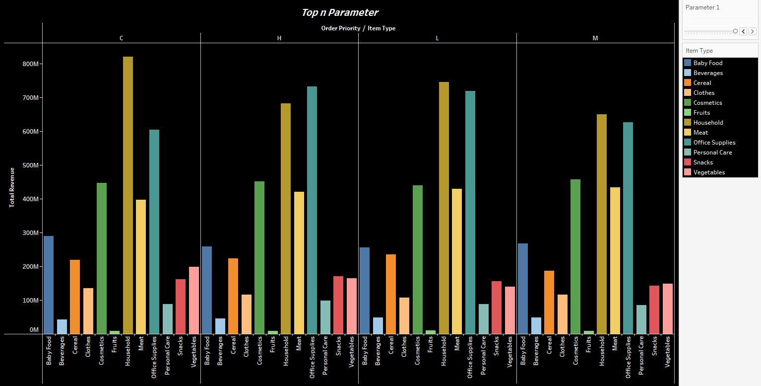

## **Definition**

A **Top N Parameter** in Tableau is a dynamic control that allows users to filter their visualizations to display only the top “N” records based on a selected measure (such as total revenue, profit, or sales). Instead of hardcoding the number of records to show (for example, just displaying the top 5 or top 10), the parameter lets you adjust the threshold interactively. When combined with calculated fields (often using ranking functions), this mechanism dynamically ranks the categories (like item types) and renders only those items that fall within the top N criteria. This approach makes your visualization adaptable and more insightful by allowing stakeholders to explore various scenarios instantly.

## **Process to Create a Top N Parameter in Tableau**

### 1. **Data Preparation**

* **Connect to Your Data:**  
  Open Tableau and connect to your dataset. Ensure you have the relevant fields such as **Item Type**, **Order Priority** (categories like C, H, L, and M), and **Total Revenue**.
* **Verify and Clean the Data:**  
  Confirm that the data types are set correctly (e.g., Total Revenue as a numerical measure) and that any necessary aggregation is in place (using SUM or another aggregation as needed).

### 2. **Create the Top N Parameter**

* **Build the Parameter Control:**
  + Right-click anywhere in the data pane and select **Create Parameter**.
  + Name the parameter (e.g., **"Top N Items"**).
  + Set the data type to **Integer** and enter a suitable range (for instance, Minimum = 1, Maximum = 20, Step Size = 1).
  + Provide a current value that will serve as the default (for example, 5 or 10).
* **Show Parameter Control:**
  + Right-click the newly created parameter and choose **Show Parameter Control**. This will allow users to adjust the number dynamically on the dashboard.

### 3. **Create a Calculated Field to Rank Items**

* **Implement Ranking:**
  + Create a calculated field (e.g., **"Rank by Revenue"**) using a table calculation like:
  + RANK(SUM([Total Revenue]), 'desc')

This formula calculates the rank of each item type based on total revenue in descending order.

* **Drag the Calculated Field to Detail:**
  + Ensure that this rank calculation is available for filtering and visualization purposes.

### 4. **Filter the Data Using the Top N Parameter**

* **Apply the Filter:**
  + Drag the **"Rank by Revenue"** calculated field onto the Filters shelf.
  + In the filter dialog, set the condition to “At Most” and make it equal to the **Top N Items** parameter. This step makes Tableau display only those item types whose rank is less than or equal to the parameter value.
* **Validate the Filter:**
  + Check that adjusting the parameter control dynamically updates the bar chart to reflect only the top N items by revenue.

### 5. **Build and Customize the Visualization**

* **Create the Bar Chart:**
  + Use **Item Type** on the Columns shelf (or Rows shelf if you’d like a horizontal bar chart).
  + Place **Total Revenue** on the opposite shelf to create the bars representing each item type’s revenue.
  + Optionally, to maintain the segmentation by order priority (as seen in the image), include **Order Priority** on the Color or Detail shelf.
* **Customize the Chart:**
  + Add data labels to display revenue figures.
  + Format colors and add a clear, descriptive title (e.g., "Top N Parameter: Item Types by Total Revenue").
  + Ensure the axis scales and legends are appropriately configured so that the visualization remains clear even when the parameter changes.

**DASHBOARD:**

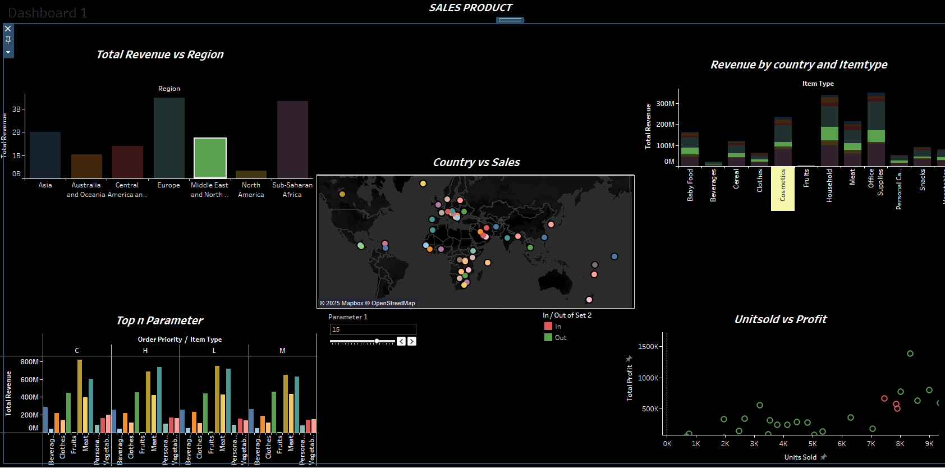

Below is an overall explanation of the "SALES PRODUCT" dashboard, which combines several visualizations to provide a holistic view of your sales performance.

### **Overall Dashboard Explanation**

The dashboard is designed to offer a multi-dimensional perspective on how your products are performing, allowing you to explore insights from global regions down to specific product and financial metrics. Here’s how each component contributes to the overall understanding:

1. **Total Revenue vs Region**
   * **What It Shows:** This bar chart displays total revenue by region—such as Asia, Europe, North America, and others.
   * **Insights:** By comparing these bars, you can quickly identify which regions are the strongest revenue drivers and which may require attention. It’s a straightforward view to assess geographical performance, highlighting global opportunities and challenges.
2. **Revenue by Country and Itemtype**
   * **What It Shows:** This stacked bar chart breaks down revenue by each item type (like Baby Food, Beverages, Cereal, etc.) while also segmenting the performance by country.
   * **Insights:** It allows for an understanding of which products perform best in which markets. For example, if certain item types generate more revenue in one country over another, targeted marketing strategies can be developed accordingly.
3. **Country vs Sales (Map Visualization)**
   * **What It Shows:** Utilizing a map powered by Mapbox, this chart places countries on a global view with marks representing sales volume.
   * **Insights:** The geographic distribution of sales is immediately visible—areas with intensity in color or larger mark sizes indicate high sales, assisting in identifying key markets and underperforming geographic areas.
4. **Top N Parameter**
   * **What It Shows:** An interactive bar chart that allows users to filter and display only the top “N” item types based on total revenue while considering different order priorities (for example, categorizing by C, H, L, and M).
   * **Insights:** This dynamic feature lets you quickly focus on the highest-performing products. By adjusting the parameter, stakeholders can explore various scenarios and identify which products consistently drive revenue.
5. **Unitsold vs Profit (Scatter Plot)**
   * **What It Shows:** This scatter plot maps the relationship between units sold and total profit. Each point is further categorized (e.g., into "In" or "Out" of a specific set), adding another layer of classification.
   * **Insights:** The plot helps to detect trends or outliers—for instance, products that sell a high number of units but may not yield proportional profit, or vice versa. It’s a powerful way to evaluate overall product performance and profitability, contributing to better inventory and pricing decisions.

### **How It Comes Together**

* **Integrated Analysis:**  
  The combination of these visualizations enables a comprehensive analysis—from the macro perspective of regional revenue to micro-level product performance and profitability. Decision-makers can move seamlessly from a high-level view to nuanced details, making it easier to pinpoint both strengths and weaknesses.
* **Interactivity and Flexibility:**  
  The inclusion of interactive elements like the Top N parameter empowers users to explore different scenarios dynamically. Coupled with the drill-down capabilities on maps and detailed tooltips throughout the dashboard, every stakeholder can engage with the data at a level that suits their need, whether they’re interested in a strategic overview or a deep dive into specific metrics.
* **Data-Driven Decision Making:**  
  Having multiple visual perspectives in one dashboard enables the identification of trends, anomalies, and opportunities. It promotes a data-driven culture where marketing strategies, inventory decisions, and regional investments can be adjusted based on concrete insights rather than assumptions.

**Conclusions:**

In summary, the "SALES PRODUCT" dashboard is a comprehensive tool that provides a detailed picture of sales performance across different dimensions. It not only highlights where revenue is generated but also helps uncover underlying patterns in product sales and profitability. This allows the business to make informed decisions that can lead to optimized strategies and improved overall performance.

**THANK YOU….!!!**